**ISHAN JOSHI**

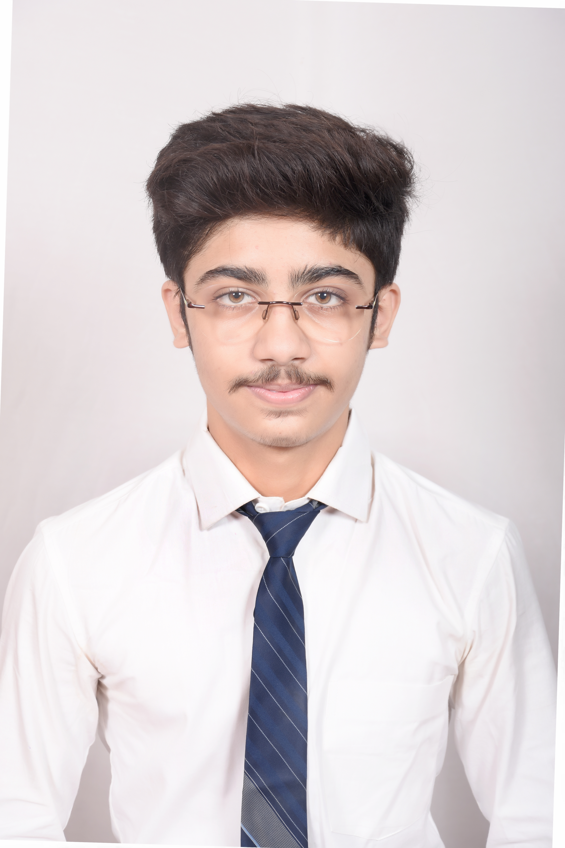

105 Pandariba ● Ujjain, 456006

● Ishan.joshi_cs20@gla.ac.in● +91 9179199191

# EDUCATION

**Bachelor of Technology in Computer Science, *GLA University, Mathura present***

**Intermediate St. Paul Convent Sr Sec School, Ujjain** May2020

**High School St. Paul Convent Sr Sec School, Ujjain** May2018

# INTERNSHIP EXPERIENCE_____________________________________________________________________________

JOVAC -June2022– July 2022

Bharat Intern – July 2023 – August 2023

# PROJECTS

**Car Price Predictor**

* In this project you can predict the price of 2nd hand cars through different categories.
* It is made by using HTML, Css, Javascript .

**Clone of Netflix**

* It was a basic clone of Netflix Streaming.
* It is made by using HTML, Css, Javascript.

# SKILLS

**Technical**

* Java (moderate)
* Python (moderate)
* MySQL (moderate)
* Web Development – HTML, Css, Javascript

**Professional**

* Time Management
* Leadership
* Problem solving skills

# EXTRA/CO-CURRICULAR ACTIVITIES

* Operation Head TEDx GLAU(2022)
* Vice President Operations E-Cell GLAU( 2022-Present )
* Head Event & Logistics E-Cell GLAU (2021-2022)

**DECLARATION________________________________________________________________________________________**

I hereby declare that all the above mentioned information is true and correct to the best of my knowledge.